WIREFRAME DOCUMENT

THYROID DISEASE DETECTION

Project By: BHARATH.N.S

E-Mail: bharathksg100@gmail.com

Phone Number: 8431547679

**Homepage**

We have developed two applications, first one in Streamlit and second in Flask. The result outcome mentioned below with picture and url link.

**1.Streamlit app**: <https://bharathksg-thyroidwebapp-app-zmudkg.streamlitapp.com/>

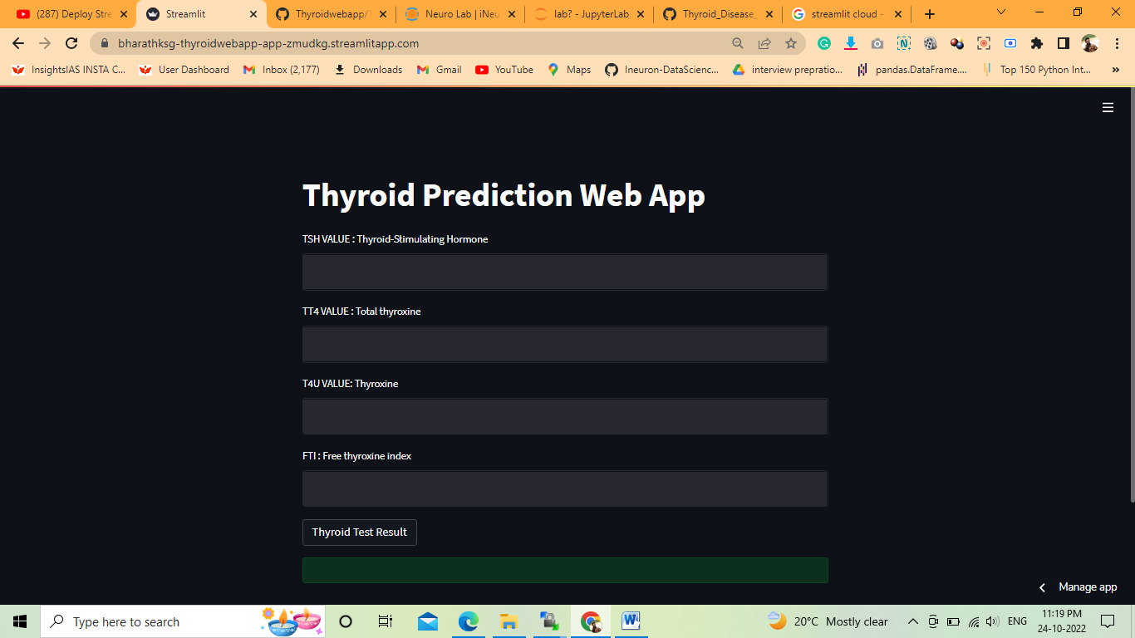

**2.Flask App > Local Environment**[**:**  http://127.0.0.1:5000/](:%20%20http:/127.0.0.1:5000/%20)

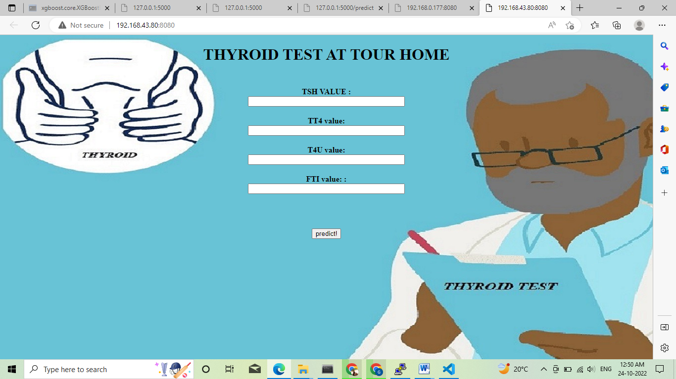

After the user enter the details and hits the predict the output will be shown as given below:

